Leader Standard Work

Purpose of LSW…..
- Policy deployment and execution, specifically create a consistent method to assure focus and alignment on the key policies needed to make the plant better, faster cheaper.
- Subordinate development

What it often becomes when mismanaged…..a system of check offs and a type of micromanagement that is both debilitating and not helpful to neither the plant nor the individual…

What is LSW?….
- It is standard work for the supervisor/manager
- It is a list of routine and non-routine activities he must do to support the True North of the facility
- It is dynamic and changes with the needs of the facility
- A process dependent system that focuses on the needs of the facility including both results attainment and supervisory support
- It is process dependent..the option is to have a person dependent or event dependent system of review and support
- It is a layered system…….
  - with LSW comprising about 80% of the Team Lead daily activities, normally around 60% of the Production supervisors activities, 50% of the Production managers’ activities and 40% of the FM activities
  - The rest of the time is allocated for outside interruptions, unexpected activities, spontaneous support and JIT problem solving
  - With layered follow ups. e. g. the team lead checks the production by hour board hourly and initiates corrective actions for abnormalities. The production supervisor checks the prod by hour board hourly and provides support to the team lead for any problems encountered. The Production Manager checks the prod by hour board 2 time per shift, intervenes on problems not yet solved and provides support for JIT problem solving and prioritization; looks for repeating issues and impacts on other parts of the plant. The FM checks the Prod by hour board daily, checks on success of problem solving and compares to trend data. Provides support to all areas affecting overall plant performance.
- Details..
  - the LSW activities must be written in auditable format
    - must be stated in behavioral terms
    - must be measurable, that is based on floor visuals
    - All abnormalities found must be highlighted
    - All abnormalities must have follow-up actions. JIT problem solving is just one of them
  - Generally, the LSW is for a week’s activities
  - There are hourly checks, daily checks, weekly checks and monthly checks - but the time frame must be specified
  - There must be a periodic review of the LSW with your boss, typically the team lead discusses it daily with the prod super, the prod super may discuss it daily with the production manager however the production manager may only discuss his weekly with the FM. To be consistent is the point, it is personnel development at its finest. For a production plant, no one who reviews LSW with their boss should exceed a weekly time frame.
- The LSW activities, when changed need to be discussed with your boss.

Preparing Leader Standard Work - Major Steps
- Create True North…so we know where we are going—4-7 key end-of-pipe-metrics
- Have facility manager (FM)make the managers matrix based on True North
- FM explains purpose of LSW, elaborating on how both aspects are important and how both aspects are executed. He is explaining and training
  - There is always a periodic review of the LSW of the subordinate by the FM
  - This provides the opportunity for training and development on a JIT basis, this is a huge and effectively step toward replacing the existing appraisal system
  - At any time the LSW can be changed if the facility needs change
  - At any time the LSW can change as the leadership is develop, more true delegation can occur.
- Facility manager makes rough copy of LSW for each subordinate…a rough, “what I expect from you” document making sure he covers clearly all the “whats” that need to be accomplished
- Using catchball, subordinates then review the document, modify and make sure it is doable….they make sure the means are adequate.
- Iterate to completion and both FM and Sub are satisfied that the “results and means” are aligned and focused
- Subordinate then repeats the process, steps 2-7 with his subordinates, returning the FM for any questions and concerns.

Using LSW to Develop Your Employees
LSW is not just a checklist it is a complete PDCA process and your role as a supervisor is to make your people successful.
- The First Meeting with Employee – Agreeing on their LSW (Print employee’s draft LSW for you and employee)
  - One-on-one (unless a collection of employees have exactly the same job and they will share a LSW document, e.g., shift supervisors of a single unit)
  - The employee should have developed the draft document of their tasks and the frequency
  - After reviewing list, you add any tasks that are needed, and frequency, with thorough discussion of why.
  - Review list and come to a consensus about deleting or modifying any of the employee’s original tasks.
  - Confirm a commitment on keeping LSW up-to-date (This will require you checking for completion on a regular frequency so it should be on your LSW. This step is separate from one-on-one meetings (another task on your LSW)
  - Inform employee that you will review LSW with them regularly and in future they bring 2 copies of LSW

- 1st Follow Up Meetings with Employee on LSW (The objective is to look and listen for abnormalities in achieving the vision of the perfect day (daily tasks), week (weekly tasks), etc. The emphasis is on the trend, not the daily one-offs. (Employee provides a printed copy of their updated LSW for you and themselves)
  - Review Daily Tasks:
    - Where do you find yourself spending your time?
    - Where would you like to spend your time or feel that you are adding the most value?
    - What do you consider to be the most important activity in your role?
{Do the responses for (i) and (iii) match with your priorities for that role? If no, begin discussion to gain consensus. Problem solving to close the gap should be the employee’s task – your job is to guide them into problem solving, NOT provide solutions}
    - Have you found it necessary to add or delete tasks since our previous meeting? Was there a prompt for this? {This is a sincere inquiry, not a challenge}
{This question is checking to ensure no priority task was dropped or someone else’s responsibility is inadvertently being added to your employee. Also, check for trends that daily tasks are being done on a daily basis. It is common for the listed frequency of some tasks to be too frequent – particularly when just beginning LSW}
  - Review Weekly and Monthly Tasks, and other longer-term frequencies:
    - Inquire about any weekly or monthly activities or meetings that you aren’t familiar with? Are they time-consuming? Does the employee consider them good use of their time? (This assumes the activity isn’t a mandatory task.)
{Sometimes weekly or monthly activities have very critical time constraints, e.g. by end of day of 24th, or Tue 12:00. If so, make sure they are noted on LSW. Consider reviews, audits, inspections that are important to the business – are they listed?}

- Subsequent Meetings with Employee on LSW - (Employee provides 2 printed copies of completed LSW)
  - Review any added/ modified tasks – Celebrate wins and completions!
  - Discuss trends in completing tasks LSW
  - Follow up on any activities identified during previous Problem Solving to close gaps (See note below 2.a.iii)
  - Inquire about problems the employee has encountered. How is it being solved? Is Plan – Do- Check- Adjust process being used. How is the employee measuring successfully and solving the problem.

LSW is PDCA
- Every process in lean is a governed by PDCA logic
- Keep in mind that we have two purposes in mind when we use LSW
  - Policy deployment and execution and
  - Subordinate development
- The two purposes are subsumed in the same Plan and Do parts of the overall PDCA process. Where the two purposes diverge is in the Check Process.
- Keep in mind that the PDCA starts with a hypothesis which is both a prespecification (“if we do these specific things”, in this case as detailed by the LSW) and a prediction (then we will get “these specific results”). These specific results are the Check and the specific results should be:
  - For policy deployment - The policies get properly deployed. That is, the goals and objectives are being met…or not
  - For subordinate development - The subordinate is developing by being able to successfully complete tasks…or not
- Which takes us to the Act step. If “these specific results”:
  - Are attained, then the standard is met and the supervisor can give appropriate feedback and take the appropriate actions
  - if they are not attained– then the supervisor must act accordingly with appropriate feedback and actions.
  - In both cases, part of the appropriate actions is to review and modify as necessary…
    - these specific things (items in the LSW that are the prespecification) and/or
    - These specific results (the predicted results in the hypothesis)

************************************************************************

An Example of LSW for a Plant Manager

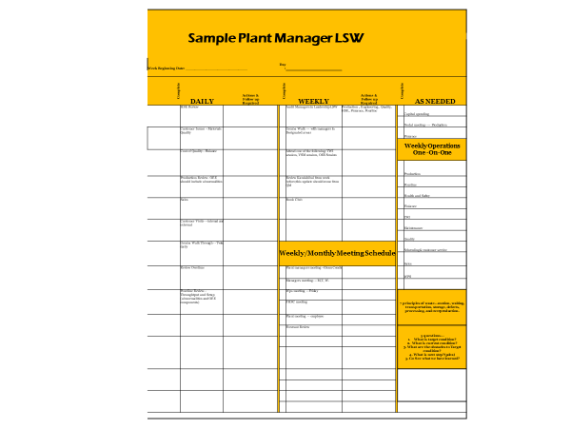

********************************************************************************************

My old hand-written example I still use in training……(this is a pdf, you can copy and paste it if you like)

